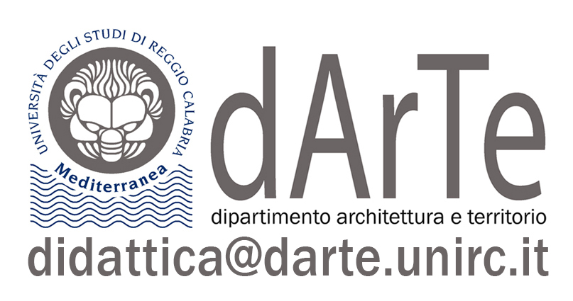
  Dipartimento Architettura e Territorio
  Corso di Studio in Tecniche per l’Edilizia e il Territorio – Classe LP-01

Degree course: | Course in "Techniques for building and the territory"
Course code:
Lecturer: | Natalina Carrà
Course name: | Territorial and Urban Planning Laboratory
Disciplinary area: | 08/E1
Disciplinary field of science: | ICAR 21
University credits – ECTS: | 6
Teaching hours: | 60
Course year: | 3
Semester: | 2
Monodisciplinary course: YES/ NO
Integrated course / Laboratory
(Specify the name of the integrated course / laboratory)
CONTENTS
1_DESCRIPTION
The Laboratory is aimed at providing students attending the third year of the course of study with progress on the major issues of urban planning discipline through the study of the topics that constitute its heritage, its field of observation and intervention, starting from its definition in the light of the theoretical debate up to its most recent conceptual and instrumental evolutions.
2_COURSE PROGRAMME
The program of the course includes the carrying out of lessons for the illustration of the theoretical aspects concerning the urban planning discipline and the methodological setting of the design exercise, and communications concerning studies and research and experiences concerning the models of transformation and enhancement of the territory, of the morphological and functional settlement forms and the new transformation dynamics that develop in the territorial contexts of reference. In particular, the issues relating to the different morphologies present in the urban reality will be addressed, read through the identification of the most significant components of the urban structure (environmental and landscape typologies, urban typologies, economic-functional structures and settlement models, nodes and infrastructure networks for transport and mobility). Particular attention will be paid to the identification and definition of the objectives of the plan and to the configuration of the organizational model of the planned territorial and urban development project/process and of the proposed project interventions.
The theme
The Laboratory deals with and explores the theme of the complexity of the city, the territory and the landscape through a reading, an interpretation and an evaluation of the dynamics of the physical and functional transformation processes that occur in anthropic space. The ultimate goal is to get to build, together with an analytical-evaluative framework of the urban-territorial reality in transformation (referring to internal territories and marginal contexts), a design vision for forms of regeneration and territorial enhancement.

The discipline will address topics related to:
- The contemporary city: materials, themes, tools, techniques
The part, of a theoretical-applicative nature and preparatory to the didactic exercise, will focus on the illustration of the changes undergone by the city and its project in the contemporary world, on the urban materials that characterize its configuration, on the themes that emerge for its reconfiguration, on the forms assumed by urban planning instruments in recent years and on the most current topics of the scientific debate related to the implementation of the UN 2030 Urban Agenda.
Therefore the following contents will be proposed:
• Urban planning today (emerging themes and issues between global and local)
• City and territory: from the acquisition of knowledge to the prefiguration of new structures; elements for reading, interpretation, representation and planning
• Elements of urban planning techniques (cartography, sizes, parameters, dimensional ratios, standards, technical characterization of the plan and implementation methods).
The experimentation
The exercise, organized through classroom activities, field surveys and workshops, is aimed at applying the knowledge acquired in the theoretical module with reference to the territorial area that will be identified as the study area. It will be structured in two main phases of work:
1. Interpretive reading of the physical, settlement and relational system of the study area, aimed at identifying their relationships, identifying the relevant characters and spatial systems that characterize them, in their criticality and quality, with attention to issues related to sustainability .
2. Construction of a design hypothesis for internal territories and marginal contexts. A design vision for forms of regeneration and territorial enhancement of a context defined in accordance with the teaching staff.

3_EXPECTED RESULTS
1. Knowledge and understanding.
The student must acquire knowledge and understanding of the main tools and techniques for analyzing and interpreting urban phenomena and the methods of representation.
2. Applying knowledge and understanding. The student must acquire the ability to read, interpret and represent the transformations of the city and the territory in relation to both the morphological and functional aspects, through the tools of urban planning. Therefore, you must be able to apply the acquired knowledge and possess adequate skills to deal with the main problems concerning urban planning techniques.
3. Making judgments.
The student must acquire the ability to integrate the various knowledge and critically reflect on the various topics proposed. All this accustoms him to collect and analyze data, to make decisions and to judge and predict the effect of his choices.
4. Communication (communication skills).
The student must develop the ability to communicate, in the form of dialogue, written and graphic, the contents learned and their proposals, adequately arguing in moments of constructive critical comparison both with other colleagues, during the course of the teaching activities, and at the final exam.
5. Learning skills.
The student must acquire the necessary skills that allow him to independently document himself on the topics studied, to use the methodological tools useful for his own cultural growth and for the continuous updating of his knowledge in the field of urban planning and territorial government, researching the sources necessary to deal with issues relating to one's professional field of competence, also with IT tools. This will strengthen awareness to recognize the need for autonomous learning throughout life and to commit to this goal
SPECIFIC COURSE OBJECTIVES
The educational objective of the course is to make students able to interpret the relationships that link the transformation processes of the city and the territory with the theories and tools of the urban planning discipline, as well as to know and know how to use the fundamental elements of the urban planning technique aimed at reading, interpretation and planning of the transformative dynamics of the city and the territory.

Qualifying educational objectives
The course aims to provide students with basic knowledge, both theoretical and applied, of urban planning tools and techniques for the interpretation and design of the city and the territory. In line with the training course of the LP-01 class and with the specific training objectives of the CdS, the Course will develop the main issues related to the salient themes of contemporary urban planning and the design tools of the discipline, so that it is immediately able to address and solve technical and design problems in the workplace.
The aim is to make students able to analyze and contextualize the transformation processes of the territory over time, as well as to understand the evolution of strategies and master the various management and governance tools of the territory.

Specific training objectives
The specific objectives are to provide an overview of the scientific debate and political strategies through the renewed interest in internal areas, which is characterized by a new perception of these places, to which the symbolic values and new use values are recognized .
The issues that have emerged in recent years concern the need to reverse the condition of marginality of the internal areas according to a place-based approach, based on places, implementing proposals capable of improving the territorial capital in a perspective of endogenous development and enhance project strategies and urban and territorial transformation processes to strengthen the resilience properties of complex territorial systems.
ACCESS REQUIREMENTS
TEACHING METHODS
1_ COURSE STRUCTURE AND TEACHING
Lessons: (classroom hours/year): 10
Exercises: (classroom hours/year):15
Practical activities: (classroom hours/year):27
Other:8
2_ AUTONOMOUS LEARNING OF THE STUDENT
The student is required to do individual work for a total of 90 hours:
- In-depth analysis/study on bibliography (theoretical part): 20 hours
- Preparation for checks (experimentation): 35 hours
- Exam preparation: 35 hours
ASSESSMENT METHODS
The exam will take place through a verification of the training path and the experiences conducted by the student. The exercises will be developed according to the thematic lines indicated by the teacher.
Some checks of the survey and graphic rendering process will be periodically carried out, in order to ascertain the correctness of the method and the adequacy of the results.
The exam, which can be accessed after verifying the minimum attendance (70%), includes both a verification of the theoretical training path relating to the topics covered during the course, and an evaluation of the graphic works prepared by the students according to the thematic guidelines indicated by the teacher.
Method of conducting the exam: theory and practice.

RECOMMENDED TEXTBOOKS
Bibliography
Carrà N., Borghi Nuovi. Paesaggi della contemporaneità, LetteraVentidue edizioni, Siracusa 2024
Gabellini P., Tecniche urbanistiche, Carocci, Roma 2001.
Gaeta L, Janin Rivolin U., Mazza L., Governo del territorio e pianificazione spaziale, Città Studi Edizioni, Torino, 2021.
Magnaghi A., Il principio territoriale, Bollati Boringhieri, 2020
Pasqui G., Urbanistica oggi. Piccolo lessico critico, Donzelli, Roma, 2017.
Secchi B. La città dei ricchi e la città dei poveri, Laterza, Bari 2013

